**Connecting Knowledge Lambeth Lesson Study Project:**

led by Rosendale Primary, funded by London Schools Excellence Fund

**What is the Connecting Knowledge Project?**

Led by Rosendale Primary School, the project was developed in partnership with UCL Institute of Education. The project tested whether our model of lesson study could improve teacher subject knowledge and have impact on pupil attainment. Research suggested lesson study could have a powerful impact on learners.

**The project involved:**

Connecting Knowledge professionals; Cohorts 1 and 2 (C1, C2). These were high quality, experienced Lambeth teachers who been benefited from professional development in the four programme elements:

1. They worked collaboratively with nominated teachers from schools across the borough to improve their practice
2. They worked to improve their subject knowledge
3. They learned about effective impact evaluation
4. They focused on developing strategies for improved outcomes for learners.

Having finished a cycle of lesson study collaboration across schools, externally facilitated, Cohort 1 additionally attended a session on how to lead lesson study with a group of Cohort 3 teachers (C3) from another school. C3 were selected on the basis that they would benefit from taking part in lesson study, although it was felt that many if not all, of this group, would also take a lead role, as champions of lesson study in their own schools.

C2 were selected for the programme in Year Two, with the intention that they would support a further cohort of teachers beyond the lifetime of the project, and probably in their own school.

Thus, the project supported:

Cohort 1: Experienced, high quality teachers identified by their schools to participate in cross-school lesson study groups in 2013/14 facilitated by an IOE consultant, and to lead lesson study in their schools and across the borough of Lambeth in 2014/15.

Cohort 2: Experienced, high quality teachers identified by their schools to participate in cross-school lesson study in 2014/15 facilitated by an IOE consultant, and lead lesson study in their schools and across the borough into 2015/16.

Cohort 3: Teachers selected by their schools as being well placed to benefit from the Connecting Knowledge approach to lesson study. They participate in within-school lesson study groups led by Cohort 1 teachers and will develop the skills to lead lesson study back in their own schools at the end of the programme.

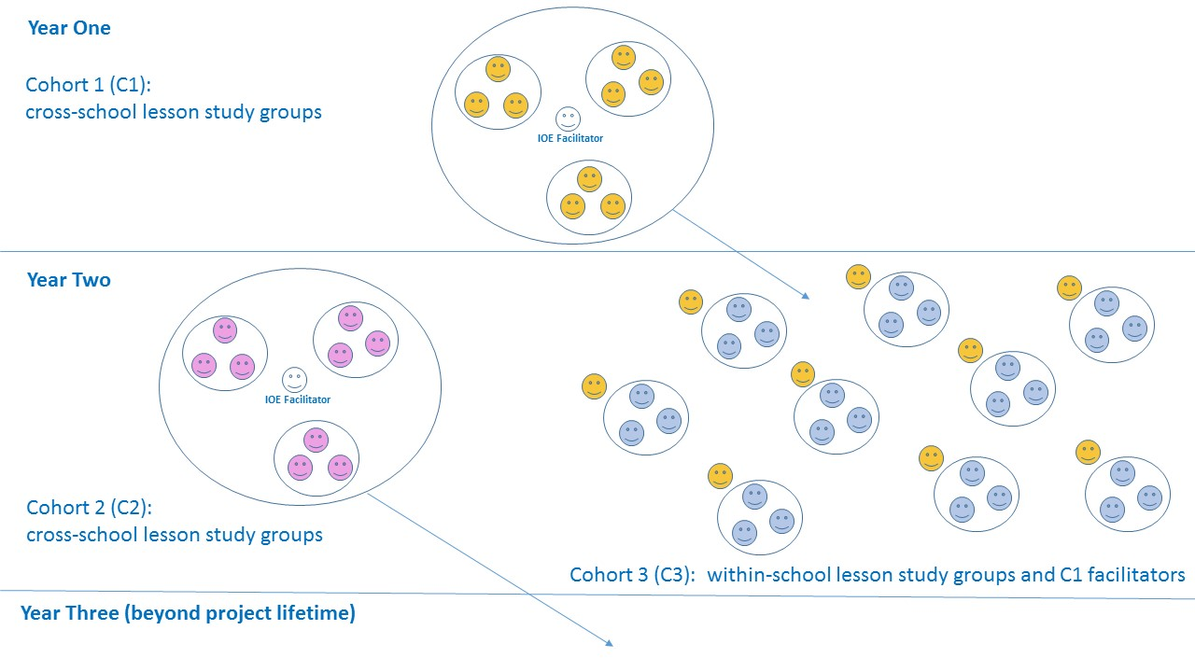

**Why was Connecting Knowledge needed?**

Across Lambeth Local Authority, attainment in mathematics was falling behind literacy for the most vulnerable at the end of key stage 2. This project aimed to address that underperformance and improve outcomes for all learners. The lesson study process in this project focuses specifically on vulnerable and / or underachieving groups of children.

**What was the impact of the project?**

Lambeth Connecting Knowledge project has provided compelling evidence of positive impact on pupils’ attainment in mathematics. This was assessed using the evidence-based methodology for assessing professional development programmes, combining Guskey’s stages of impact and UCL Institute of Education’s impact framework design. A wide range of evaluation tools at different stages of the project, was used to confirm this.

In Year One, Lambeth Connecting Knowledge set out to give a group of teachers (already designated lead professionals in mathematics) experience in lesson study for professional development. In Year Two these C1 teachers successfully led groups of teachers to conduct Lesson Study in their schools. C3 teachers benefited from the professional support and facilitation for lesson study by the C1 teachers. Also, an additional group of teachers (C2) benefited from professional development to become leaders of lesson study.

All teachers responded very well to the experience. Teachers enjoyed the collaborative aspects of lesson study and the support and challenge they received from colleagues. Importantly, lesson study was seen as quite different from other lesson observations. Specifically, the focus on improving teaching and learning and on the needs of particular students was a common feature of teachers’ feedback on the particular benefits of lesson study as an approach to professional development.

Well facilitated lesson study sessions led to insightful observations of pupils’ learning that sometimes challenged teachers’ own pre-conceptions about particular pupils they taught. The extra pair of eyes in the class and detailed post-lesson discussions meant that high quality lessons were planned and subsequently improved in relation to their effect on pupils’ learning. The supportive lesson study groups helped to encourage risk taking and innovation in the majority of participants.

Improvements in the lesson study process from Year One feedback ensured that headteachers were better informed about LS principles and that teachers were more focused on planning lessons that would have a direct impact on their focus pupils. Implementing a two lesson LS cycle also meant that focus teachers could benefit from a developmental cycle with the feedback and encouragement of their colleagues.

Independent assessments of LS processes revealed a high quality of engagement with the core philosophy of LS (focusing on pupil learning). Interviews with C1 LS facilitators suggested that senior leader support was essential in ensuring that high quality LS cycles are maintained beyond the scope of the project. Discussions about the future of LS in the participating schools showed variation; the majority aiming to continue learning from LS. Across the participating Lambeth schools the trend was to maintain and in some cases extend LS engagement. The ability and will of senior leaders to protect teachers’ time for LS was seen again as the key ingredient.

Highly significant shifts were shown in teachers’ pedagogical skills. Teacher self-evaluations on nine aspects of pedagogy showed significant shifts in eight of them. Large effect sizes were seen for skills in: considering pupil voice; thinking about longer term learning goals; building on pupils’ prior learning; developing higher order skills, embedding assessment for learning and inclusivity. These results suggest that the lesson study process has helped teachers to reflect on a wide range of subject pedagogy that is likely to have benefitted pupils they teach outside of their target group and also those they will teach mathematics to in the future. In relation to their target pupils, teachers reported a range of gains, in particular how to attend to the needs of these pupils and how to break down learning into manageable steps.

Attainment of focus pupils increased significantly in both years of the project. Teachers set aspirational targets for these pupils, not just to bring their rate of progress up to the average, but to accelerate this and attempt to bring often struggling students up to the level of their classmates. Teacher assessments of achievement showed that these attainment targets were met in a large number of focus pupils and these reached very high levels of statistical significance. Qualitative analyses showed numerous examples of pupils developing number skills and mastering problem solving strategies. Pupils were also more able to articulate their learning process while solving mathematical problems. In addition, many teachers remarked on the increase in focus pupils’ confidence, collaboration in learning tasks, resilience and perseverance.

The project corroborates the LSEF’s theory that investing in teaching, subject knowledge and subject-specific teaching methods and pedagogy will lead to improved outcomes for pupils in terms of attainment, subject participation and aspiration. The Lambeth lesson study project involves investment of time for collaborative research and in expertise (in the form of ‘expert’ IOE consultants), leading to improvements in pedagogical content knowledge for maths, which enable improved learning experiences and outcomes for pupils.

**What were the key enablers and barriers to success?**

The evaluation philosophy focused on impact at pupil level with a logical chain of inference, starting with teachers working on their professional learning and leading to them practising the new skills to the benefit of pupils. Encouraging senior leaders to support and understand the principles of lesson study was seen as vital and aided by a guidance sheet developed alongside lesson study leaders. Lesson study cycles were timetabled formally and this created sufficient space and quality interaction for much to be learned about the pupils and also for wider pedagogical knowledge to be gained.

The role of the IOE as ‘expert’ other was crucial to the success of the project. The IOE consultants brought expertise around lesson study but worked alongside lead teachers to find ways to co-construct a lesson study model that met the schools’ needs. The process of co-construction enabled the development of a model that worked in the local context and was flexible enough to meet the needs of individual schools, yet remained true to the core principles and practices of lesson study. Regular engagement with teachers and quality assurance of the implementation of the project proposals meant the project could gradually refine its design to ensure a best practice model for local circumstances.

The IOE also developed a set of evidence-based, robust impact analysis tools that would capture impact at teacher and pupil level. Again, IOE consultants worked with Cohort 1 teachers to design and pilot these tools to ensure they were fit for purpose and reliable. This support enabled the project to demonstrate its impact with rigour and precision.

**What were the most effective management and delivery processes?**

Excellent communications between each stakeholder in the project contributed to its success: planning, external facilitation, collaborative discussions between external IOE evaluators and school leadership. Building in evaluation throughout the process was also key to its success.

The role of project manager was crucial in terms of keeping the project on track, maintaining communication and project momentum. A project of this scale would be impossible for a teacher or senior leader to manage effectively alongside other school responsibilities.

**What is the focus for future sustainability?**

We are running a small lesson study project with a small group of schools in the autumn term 2015, based on Connecting Knowledge. We have trained 19 teachers in 14 schools across the LA to lead lesson study. Further, Rosendale School regularly holds CPD days for teachers and leaders from local, national and international schools.

Teachers and leaders from Rosendale School are regular participants in local and national events focussed on sharing good practice so forums for sharing the findings from the project are extensive.

The key to sustainability is developing an understanding amongst school senior leaders about realistic time commitments, and organising mutually agreeable dates for participating schools. Partner school senior leaders as well as the project team can then work collaboratively to meet the expectations of participating teachers. Memorandums of Understanding are of vital importance to this process of agreement and commitment.

There is a need to explore models of lesson study that are less time-intensive at school level and this is being explored in the continuation project, possibly through an increase in ‘open house’ research lessons to which observer teachers can be invited.

**What should schools running a project like this consider?**

* The importance of enabling participants to become ‘leaders’ of lesson study through the facilitation of relevant professional learning and support materials (such as a lesson study handbook) in order to build capacity for sustained impact;
* The role of the external ‘expert’ and the need for them to work collaboratively with stakeholders to ensure maximum impact;
* The role of the project manager as someone external to the school who can dedicate time to the successful organisation of the project;
* The need for carefully constructed evaluation tools to measure impact in line with the project’s theory of change;
* The value of having a pilot year in order to deal with any minor difficulties and tighten the focus on impact at pupil level.